Sean Morrison, Chris Choi, Finn Holohan

Professor Plotka

ITWS 1100

8 December 2022

Term Project Final Paper

**The Proposal:**

While we were researching for ideas, we found that finding charities was a strenuous process. Websites were cluttered with ads, the user interfaces were hard to navigate, and the process in general was time-consuming. So, our solution was to provide a simple way for a donor to discover the charity they were looking for, especially the one that best fit their needs.

During the planning stage of our project, we decided on a couple of features and criteria we wanted our website to have. Firstly, we wanted our website as user-friendly as possible. We wanted the website to be easy on the eyes, and uncomplicated to navigate. To differentiate ourselves from competitors, we also decided on having no ads, as that takes away from the user experience. Some feature we wanted our website to have was a profile option. If users choose to sign up, they can create their profile and add charities to a list to keep on giving. No more searching around and clicking button after button to get to the charity that you need. As an added feature, there is also going to be a rating of the charities on the side by how trustworthy they are, along with their overall rating as a charity, making choices for users much easier.

As we delve deeper into our project, the core idea of our project was unchanged, however, we did decide to forgo and change a lot of the features we were originally deciding on doing.

**Our Process:**

We first designed the looks of our website through Balsamiq. Taking key points away from the Human-Computer Interaction guest lecture we had, we decided to keep a simple look to our website. After our design mock-up was finished, we moved on to coding our actual website. We first started with HTML and CSS to get the basic layout of the website. We first set up our website to model the mock-up, later, however, we decided to change that. With new ideas for improvement and a consensus on what we wanted our final project to look like, we came up with our current design. As seen below, we have a general color scheme of light blue, white, and black. We sectioned off the website into 3 spaces. The header, which contains the logo, along with the 4 tabs to navigate the website. A body area, which contains the content of the website (this is where a list of charities would be shown, our help page info, or our about page info). And finally, a bottom header, which contains our names along with a link to each one of our LinkedIn.

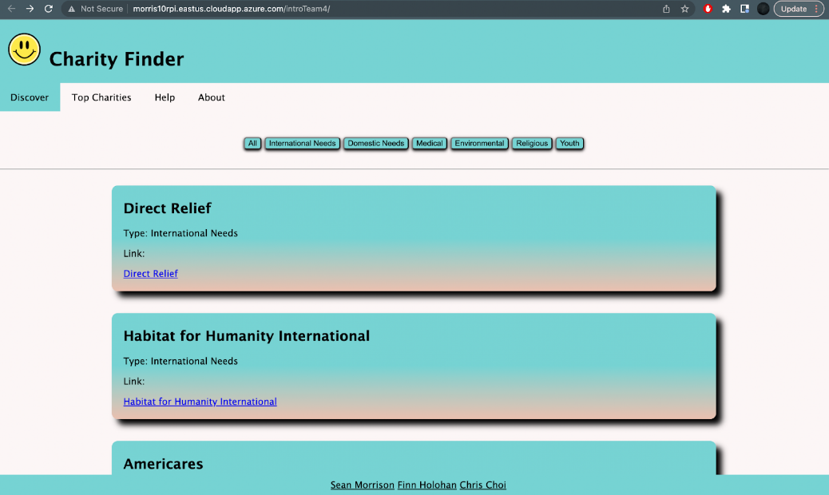

Another important part of our project was based on our JSON file. This was the core of our website.  Our JSON file carried a list of the top 100 charities which was sourced from Forbes. Each listing contained the name of the charity, the rank 1-100, the URL to the charity homepage, and a type that categorizes each charity. This information was shown with the use of JavaScript and AJAX later.

Building our JavaScript file proved to be one of the more challenging processes in our implementation. The first part of building the JavaScript file was to read our JSON file and display them on the page. Besides the syntax errors, this part was rather easy. The second part of building the JavaScript file was adding functionality to the navigation menu. Our site is separated into div elements rather than separate .html files.  Because of this, the first approach to the JS file was to keep track of the currently selected div element and hide all other div elements. This process did not end up working correctly, so we approached the problem in a similar, but different way. On the click of a navigation bar button, it will hide all div elements, and only after, display the one div correlated to the button. We created a function to loop through each of the division tags and hide them. Our website, however, posed another problem. Some of our divs contained embedded divs, and because of the way that the function .hide() works, is that it hides all divs and the divs contained within those divs. Yet, .show() does not work that way, in that it only shows the element that it is called upon, i.e., the outermost div. In order to overcome this problem, we implemented a way to keep track of the divs that were currently ‘active.’ We used the .addClass() and .hasClass() methods to keep track and make sure all of the current divs that were active, were being hidden, and vice versa.

While developing our website, our group had our fair share of challenges along the way. One of the main problems was to find a desirable ‘look’ that we all could agree on. While we did want to follow and copy the mock-up, created in Balsamiq, we found it difficult to implement everything we had planned to do. Also, we wanted the website to be a bit simpler than our mock-ups, and thus came what we have currently. Another challenge we faced was the implementation of the search bar. We decided to scrap this part as the search algorithm that would search the web for a specified charity proved to be too difficult and we could not guarantee an ad-free experience.

**Summary:**

In the end, we are pleased with the outcome of our project and believe this will make a positive impact in the charitable sector. We also met our original goal of the project, to create a simple and user-friendly website that searched for charities.

One thing we all learned was how much effort goes into building a website from scratch. Although our idea was simple, we still had a lot of trouble brainstorming and implementing our ideas into code. The mockup helped with this and we learned how useful a mockup could be. We were also surprised at how much our website changed throughout our development process.

In the future, we would like to create a profile section for our website. We think it would be a great idea to be able to add a user to a database so that the user would be able to add their favorite charities into a personalized tab. This addition would greatly reduce the amount of search time for a specific charity. As well, we would charge nothing to sign up for our services. Lastly, we plan to try again with the implementation of the search bar, this time, however, keeping the sort buttons. The sort button helps users to browse through categories, while the search bar helps the user search for specific charities by name. In the end, we hope to continue to add features that will improve the site's functionality and efficiency.